**ONLINE MENTORING SYSTEM**

**Abstract**

Mentoring is a conventional method of transferring knowledge and ideas from confirmed professional in an society to an inexperienced member in the sector. Education sector has found mentoring as quite effective tool since long back and with the advent of new technologies, comes an idea of online mentoring, which is also referred to as e-mentoring. Instead of face-to-face meetings, Online Mentoring System (OMS) uses asynchronous ,electronic communications to establish and support the relationship between mentor and the student using virtual mode. E-Mentoring uses computerized medium to transfer knowledge and skills from teacher to student. It basically focuses on student and faculty relationship. Online Mentoring System is a Client Server model, which acts as an Interface between Teacher and Student. OMS strives to reduce the work load of students in entering their details and at the same time enable the Mentors to assess their students more efficiently. E-Mentoring is fundamentally developed to improve the performance of students by assisting mentors to understand the problems of students more effectively and easily. In order to achieve this, a review system is also included.

**INTRODUCTION**

To Development and securing of excellence human resources under both the internal and external environmental changes are a key deciding factor of the national competitiveness. However, due to the poor vocational training or career guidance services in college. The colleges have not been playing its role in the transition to the professional world for their students, who consequently cannot meet the demand from industry. Currently, most of colleges provide students with relevant information and vocational guidance via systems such as an on/off-line career information office or consultation center , and an internship. However, since a systematic connection between individual students is not made, its effect is utterly limited. Vocational training or career guidance service in the college is poor, And thus colleges cannot play its right role in the transition of college

students to the professionals stage after graduation. Therefore, it is considered that college graduates generally cannot meets the demand from Industry.

**Objective**

Online Mentoring System Project is web-based application developed in java programming language . The main aim of project is to develop a platform where people can interact with mentors of different categories . It can be implement in any organization or college.

**System used and Specifications:**

**HARDWARE:**

**RAM**  : 8 GB

**Processer** : Intel i5

**OS** : Windows

**SOFTWARE:**

**Database** : MYSQL

**IDE Tool** : Eclipse IDE

**Technologies** : Servlets, JSP, JavaScript ,Boot strap, HTML5, CSS

**Modules**

|  |  |
| --- | --- |
| **Primary Actor** |  |
| **User** | Sign in  Registration  Login  Modify Details  Add mentor  Schedule meeting  Add review |
| **Admin** | Login  Manage users  Add categories |
| **Mentor** | Sign in  Registration  Login  Mange mentees |

**UML DIAGRAMS**

**Class diagram**

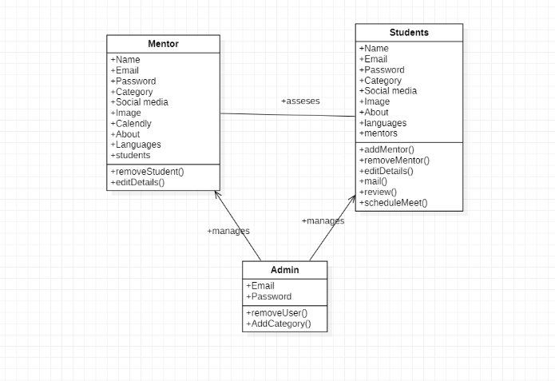

**Sequence diagram**

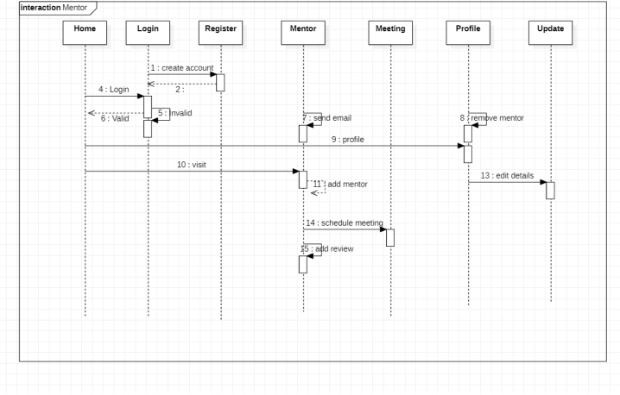

**ER diagram**

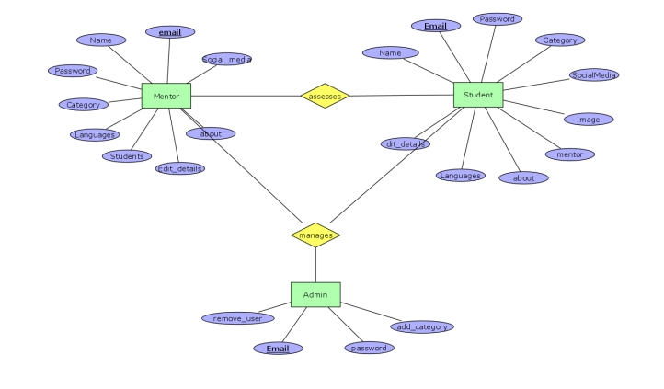

**Use case diagram**

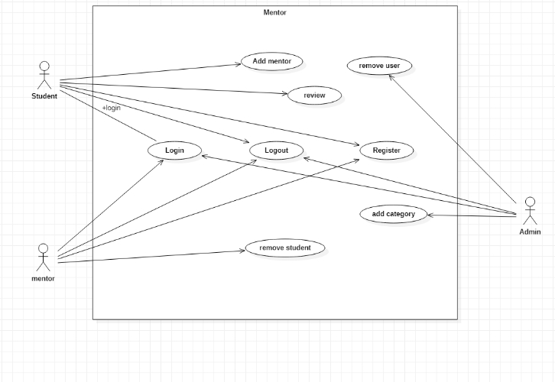

**Data Dictionary**

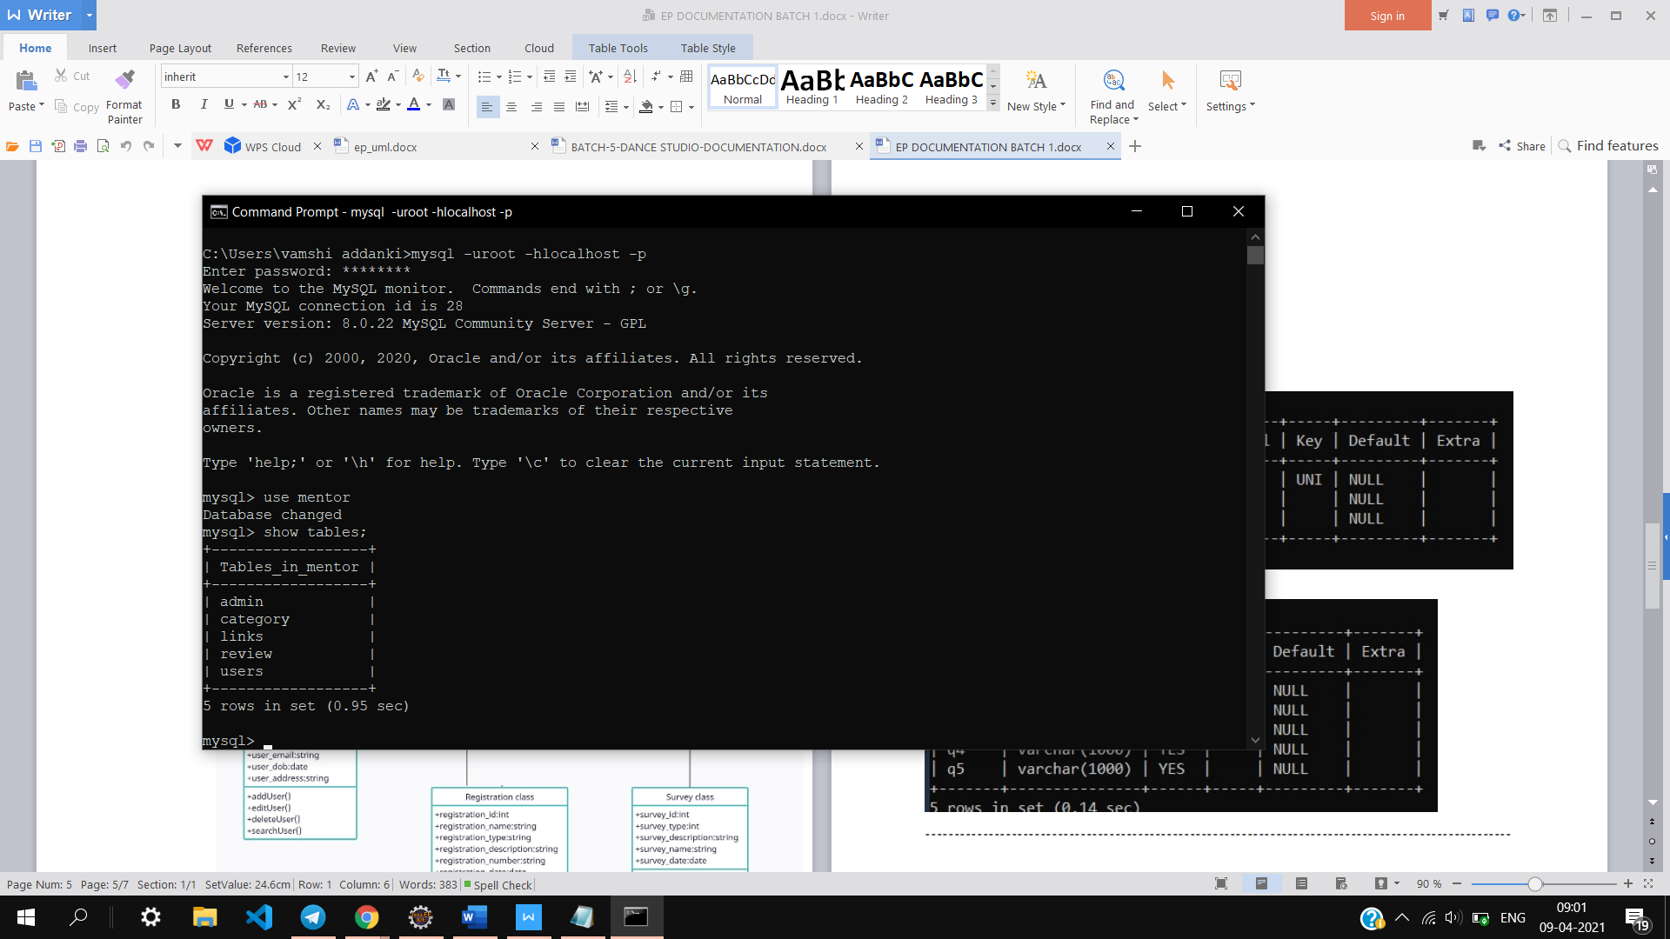

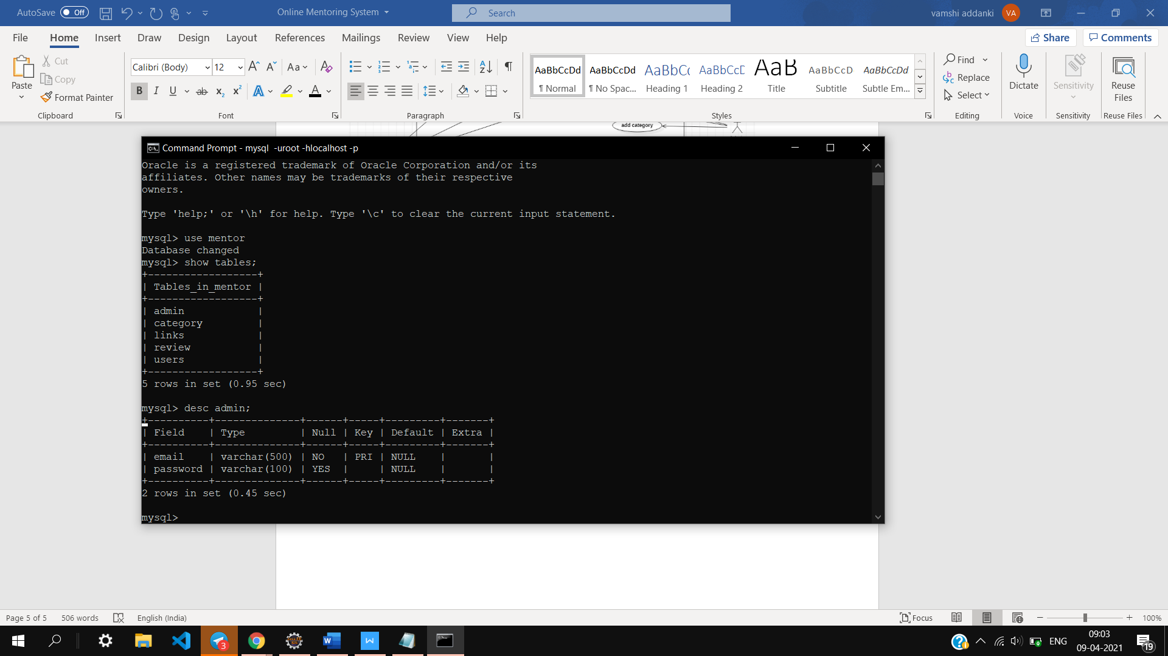

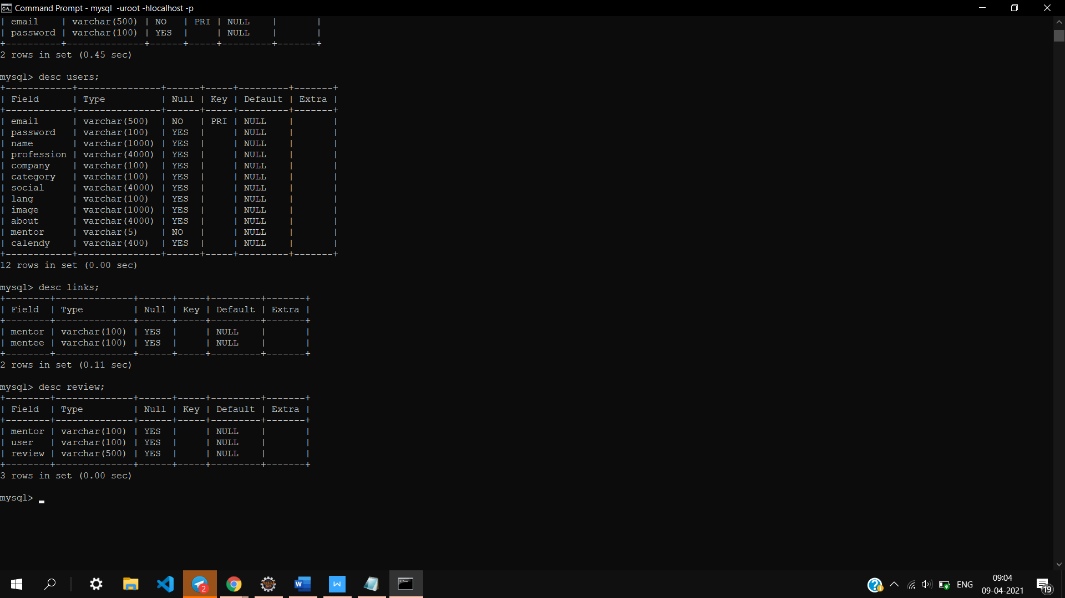





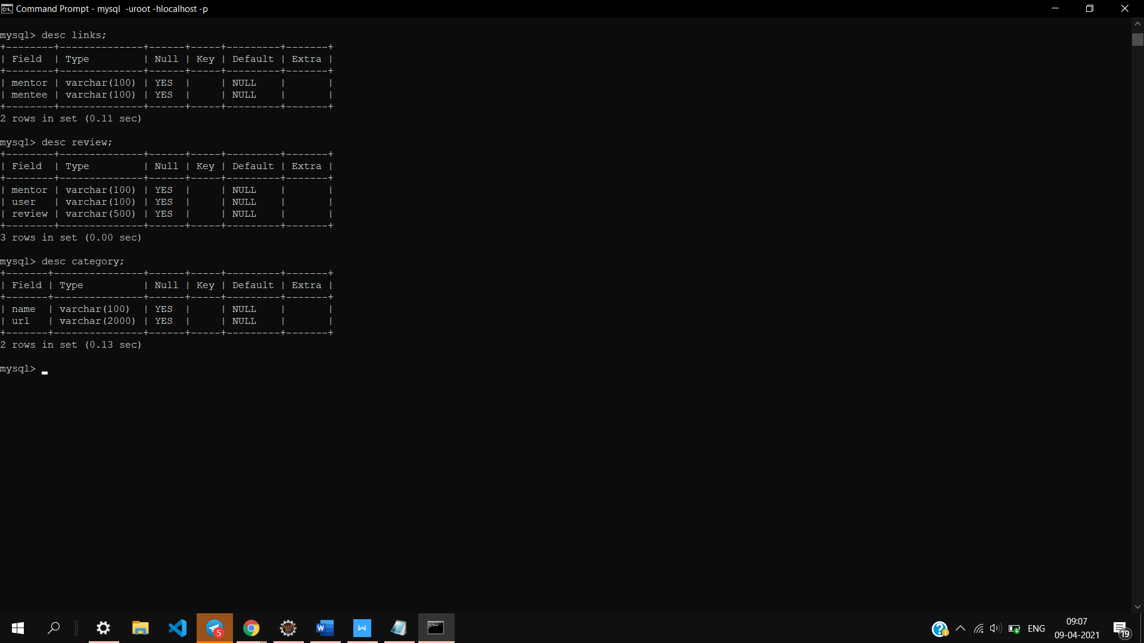

**Project Overview**

**Home page**

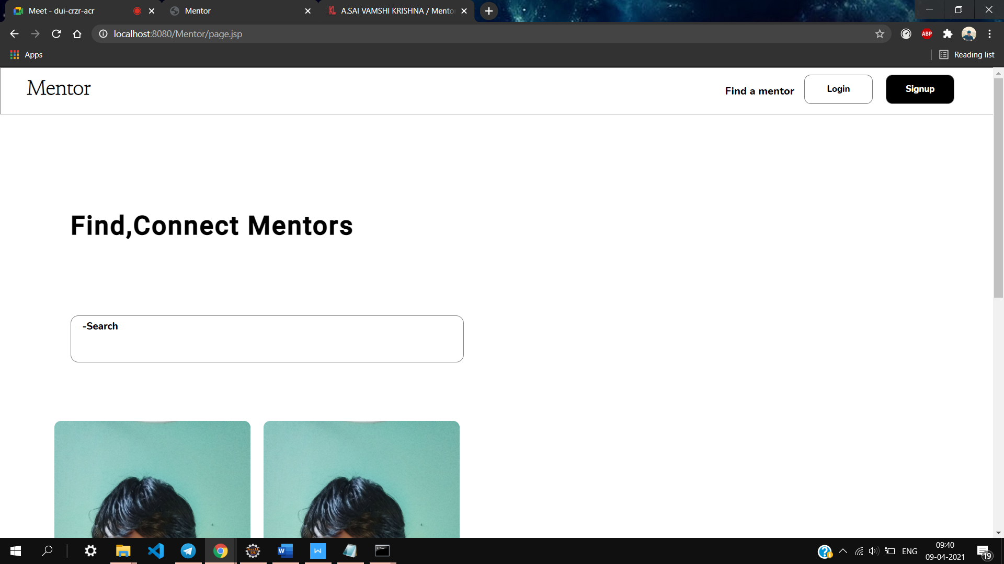

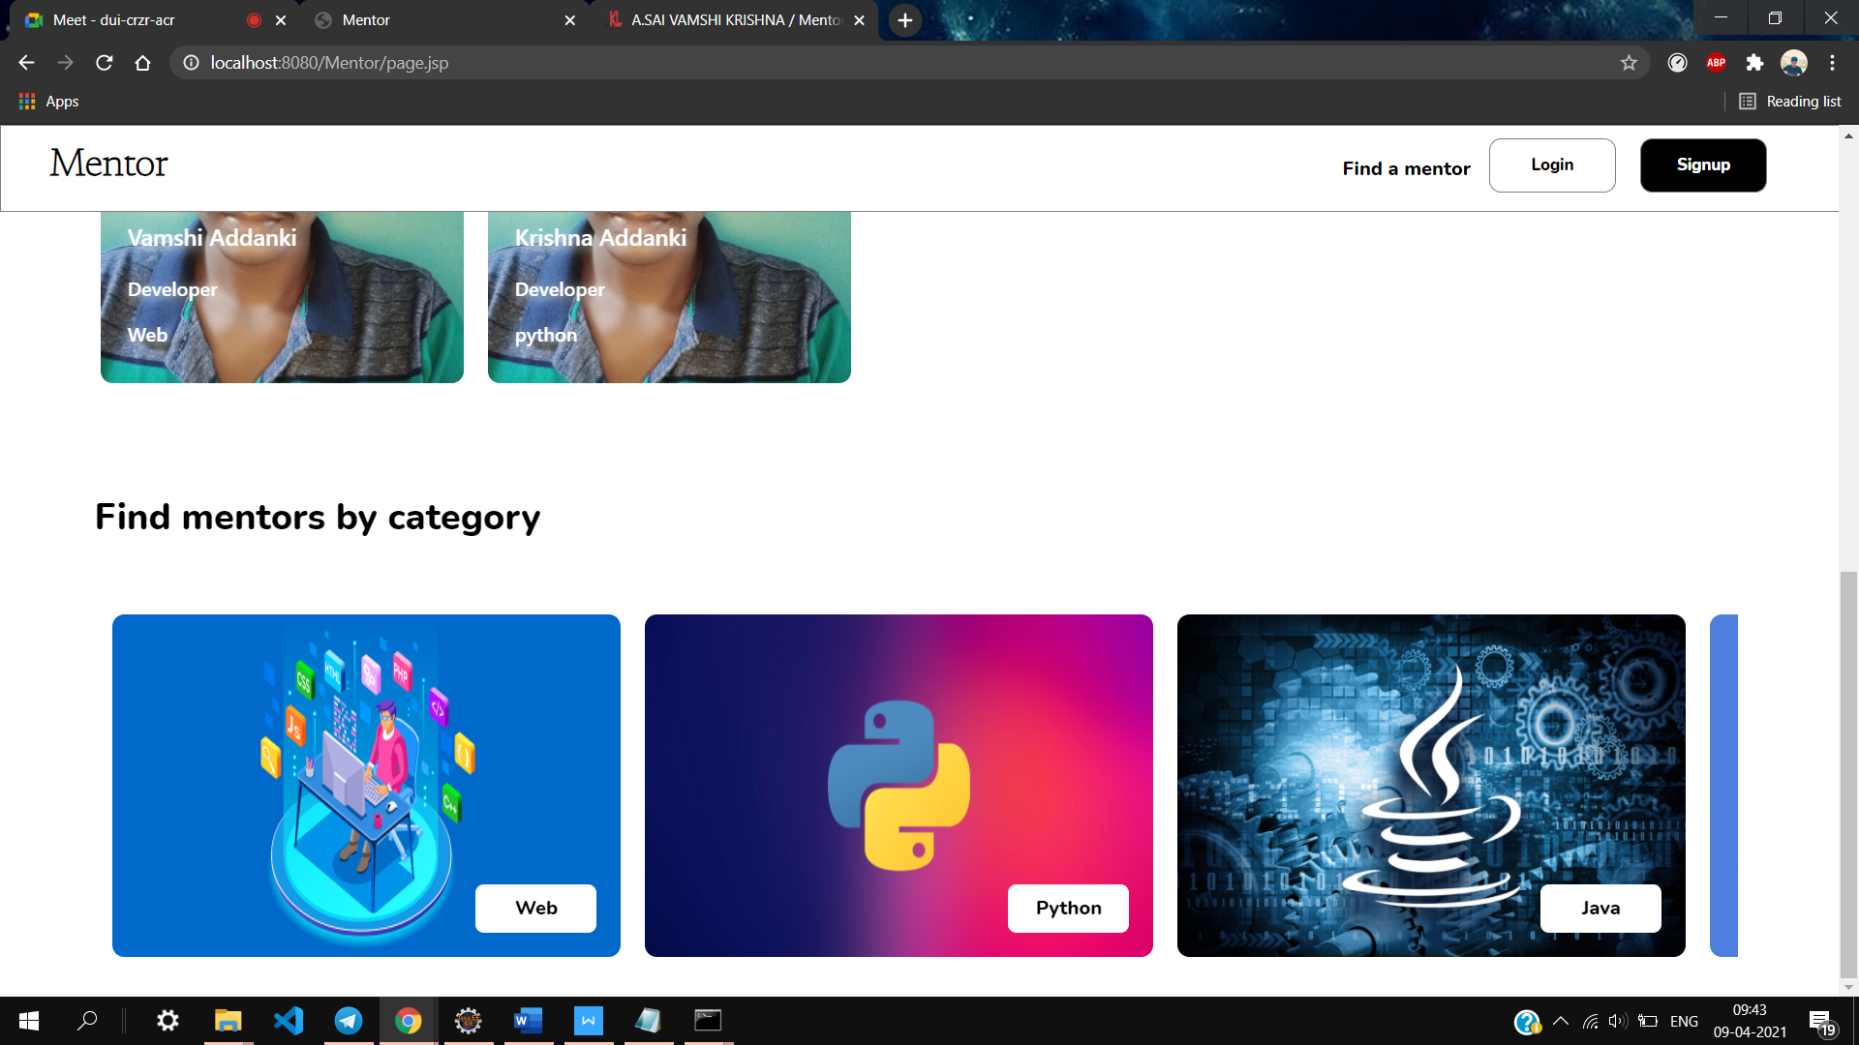

**Login page**

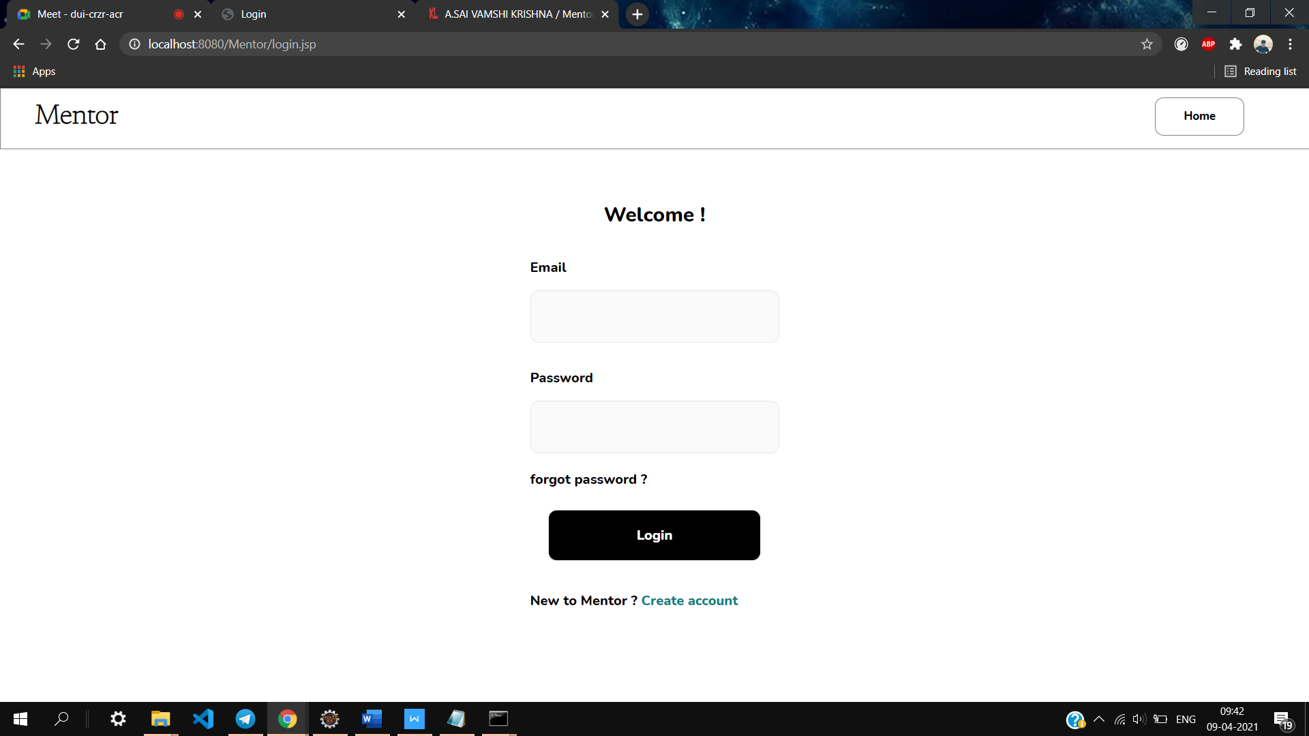

**Sign up page**

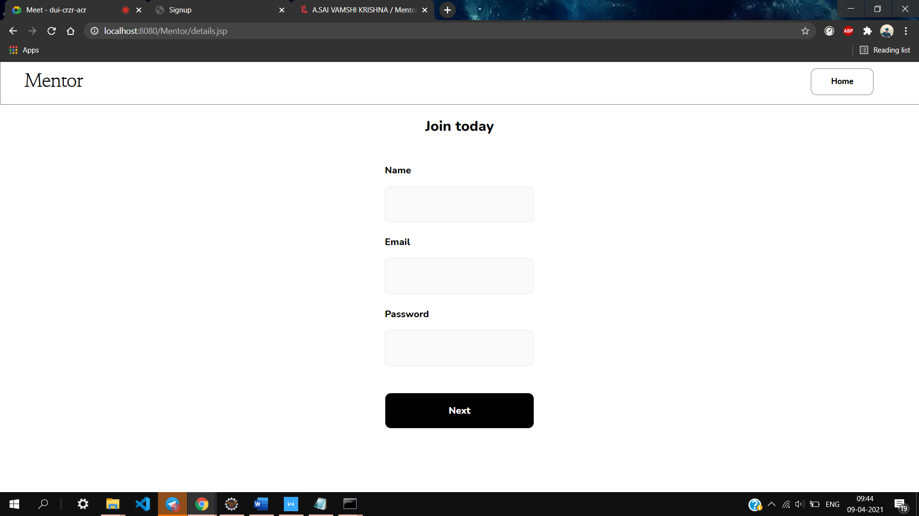

**Mentor page**

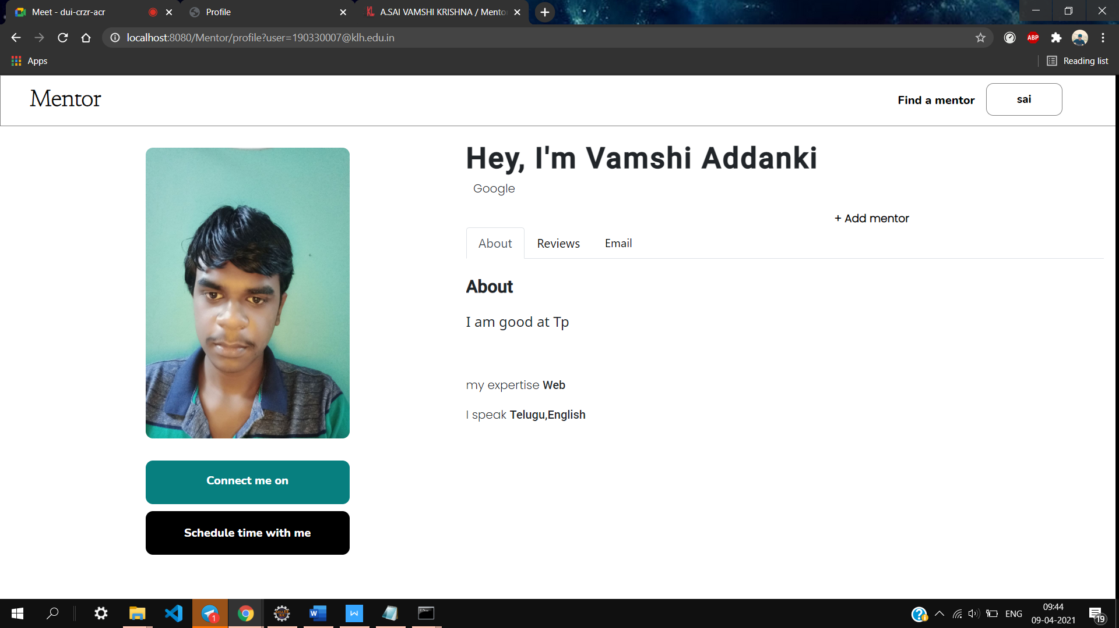

**User page**

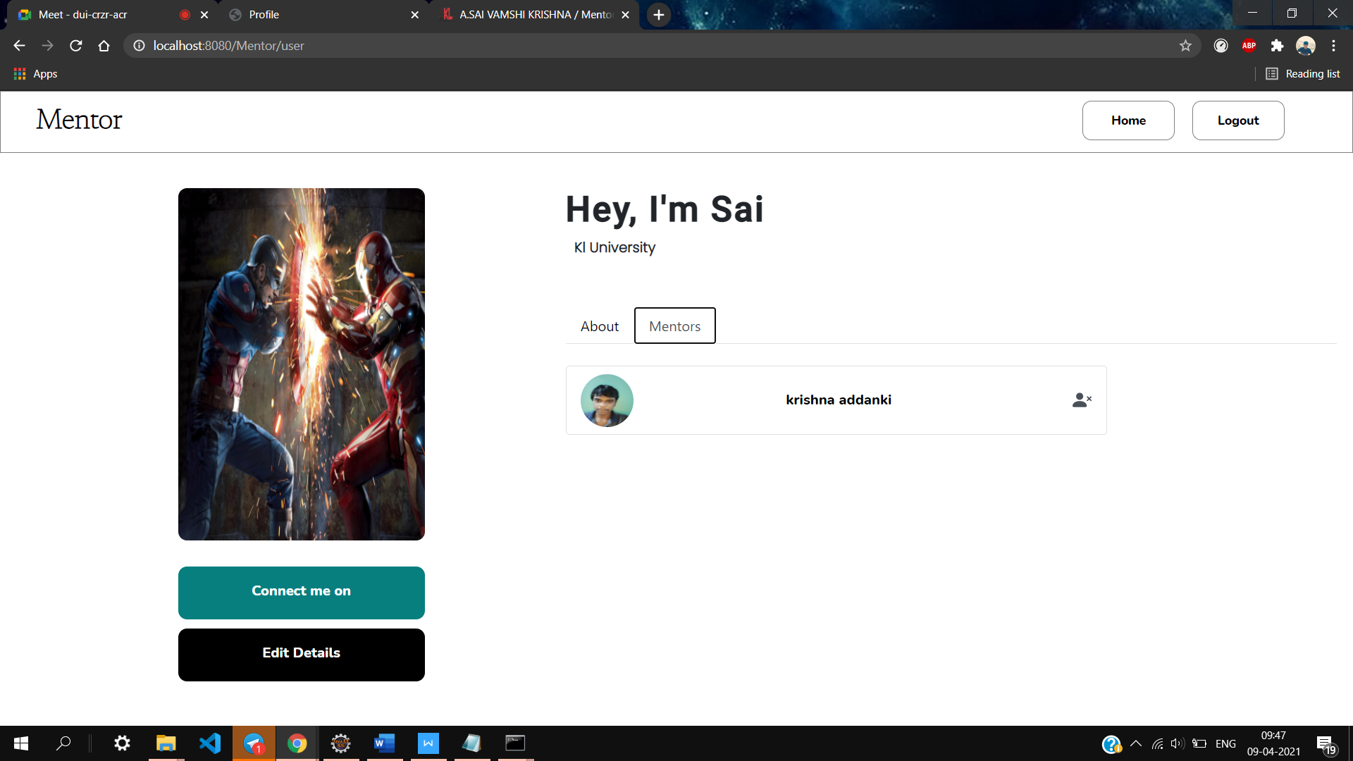

**Admin page**

